**History of Social Media Marketing :**

Social Media seems to be a new trend, but its roots stretch to the beginning of computer era. What we see today is the result of centuries-old social media development. **Usernets,** which was launched in 1979, was the first progenitor of social media, and the journey from Usernets to Facebook is a long one. Usernets allowed users to post on newsgroups. It was followed by **bulletin board systems** (BBS) which allowed users to login and interact. Online services like **progidy** were the precursors to BBS. After online services, internet relay chat came into light which gave way to instant messaging.

In the 90s, dating sites and forums were on peak, which led to the development of social networks. But they did not let users make friend lists. **Six degrees** launched to overcome this feature. It allowed profile creation and listing pears. It was purchased and shut down after playing for a decade. Blogging emerged in this phase, creating a sensation in social media. It is popular even today. Other sites like **BlackPlanet** (African-American Social Website) and **MiGente** (Latino) cropped up having provision to create profiles and add friends.

Modern social networks came into picture post 2000. Apple launched its **Friendster** in 2002. It has millions of users. **Hi5** and **Linkedin** were launched in 2003. Linkedin is a ground for professionals to reach out to one another. **MySpace** also originated in 2003 and became well known by 2006. Similarly **Facebook** was launched in 2004 and surpassed MySpace, Orkut, Multiply, etc., and is still expanding. This decade also conceived media sharing platforms like **photobucket, flickr, youtube, instagram,**etc., along with news and bookmarking platforms like **Digg** and **Delicious**.

Since 2000, Social Media has bloomed to horizon and is still expanding limitlessly. Along with media sharing, many other portals that provide real-time updates were introduced, for example, **Twitter, Tumblr**, etc. In 2007, Facebook launched its advertising system.

**The Importance Of Social Media Marketing**

Social media has become the most influential and important virtual space where the platform is not only used for social networking but is also a great way of digitally advertising your brand and your products.

Social media's power is commendable as you get to reach a large number of people within seconds of posting an ad, helping you reduce your costs, and making your ads reach out to your potential audience through these social media advertisements.

With the huge number of online users, which is almost 59% of the world’s population, marketers must not miss out on their chance of marketing on these digital forums where they can reach all the maximum number of potential buyers compared with print or television media marketing.

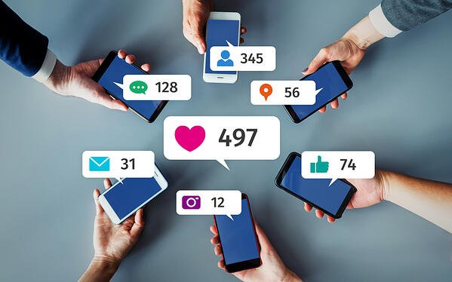

## 10 Reasons Why Social Media Marketing Is Important For Your Business Or Brand

It is important to use platforms that are commonly used by customers so that you can reach out to your target audience at a more effective rate.

Nothing can be better than these social media networks where most users spend a larger chunk of their time during the entire day and night.

Being a business on social media networks, you might want to make the most out of these consumers' habits, which can help you create some major leads.

These social media channels help you attract the right customers with the right information at the right time and help you showcase your product or brand to potential customers at the right times.

This is how the mechanism of such social media websites works.

It gives you a chance to make the most out of your social media marketing strategies.

**Here are 10 reasons why social media marketing is important for your business:**

### **Reason 1: You Get To Tell Your Story**

Having an online presence as a business on any of the social media forums like Facebook or Instagram is a great way to interact with your audience and to really connect with them on a personal level.

Which gives you the chance to tell your story to all your followers and inspire them through your success or past failures.

Social media is a place where interacting with your audience gives you more exposure and helps you better understand your audience.

Your customers will be able to know you and relate to your stories on a more personal level as well, and this is exactly what you need as an entrepreneur in this digitally connected world.

People who don’t know you or your business might find it intriguing to know how you build up your business and, thus, through these posts, you can create brand awareness about how hard you worked to make your dreams come true.

This will add more meaning to your brand, and customers love it more when they see the realities of businesses.

And to make sure that your story is heard and spreads at a faster rate, you might want to work on your content so that it is appropriate enough to impress the audience.

### **Reason 2: You Can Grow An Audience With A Small Budget**

Social media advertising has to be one of the least expensive ways of marketing your business digitally.

With so many different advertising tools available on these social media forums, you can make use of this opportunity and cost-effectively market your product.

The best thing about social media marketing is that you don’t really have to use the adverts or ad tools to market your brand.

You can grow as a page on social media networks by simply being consistent and posting interesting and relatable content for your audience.

This can be done by using SEO content, where you use the most trending keywords and enhance your rankings.

And because the digital competition is always on its peak, you might want to keep your SEO game on point.

Once your social media marketing is strategized effectively, this would help you increase the traffic on your profiles on these forums, which will eventually lead them to your websites.

There are a number of businesses and bloggers who have spent not even a single dollar on a digital advertisement, but just with the help of great content and great interaction with their audience, they created a customer base who connected with them.

This means that even if you have a smaller budget for advertisements, you can help your business on these social networking forums, where through increased marketing, the process of digital growth for your brand quickens.

### **Reason 3: Stay Top Of Mind With The People Who Matter The Most**

Business owners need to be vigilant on social media networks and need to create an image of their brand such that it is the first thing that comes to your customers' minds when they think about a certain product or service.

For a target audience with the potential of becoming buyers, it is important that you are connected with them through these social media forums, creating an impression on their minds so much that your business is on top of their minds whenever they search or think about buying a similar product.

This bond between a business and a potential buyer plays a significant role in converting them from just a potential customer to a loyal and regular one.

And this is what social media marketing helps you create.

It helps you as an entrepreneur to become the first choice, the first thought, or the first preference for all the customers who can be important for you and your business.

### **Reason 4: Learn About Your Competitors**

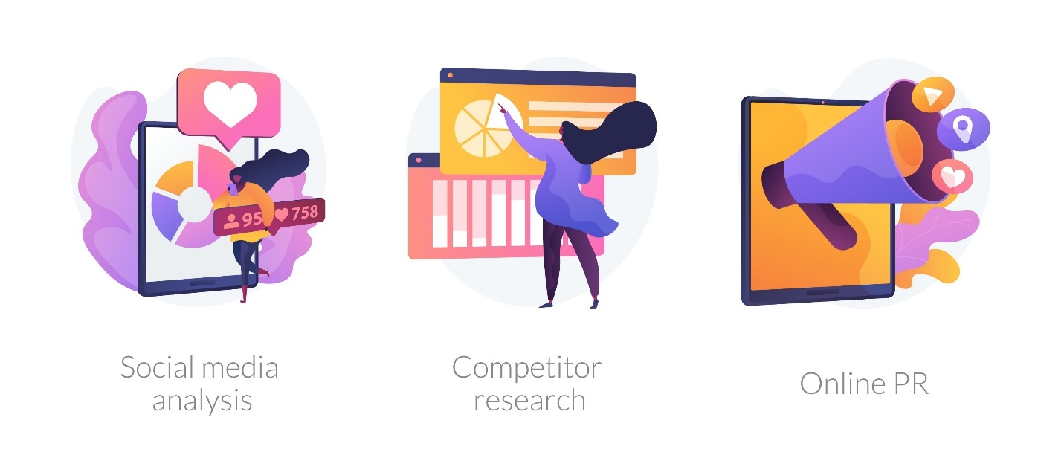

With all business profiles on all social media networks accessible to the public, this could be your chance as an entrepreneur to know your competitor better and understand the strategies that they are implementing to attract their audiences.

You would be able to see the content that they are posting on their social media profiles and judge which posts are doing better.

After carrying out this analysis of your competitor’s profile and looking into all the queries asked by their audience, you will be able to incorporate those questions into your digital marketing strategy.

Go through their posts, their comments, and how they are engaging with their audience.

Read the questions that their audience has asked and see how you, as a business, can answer these questions.

Research more about how well informed their audience is and how aware your audience is.

Based on these comparisons, you will be able to answer these queries better and make yourself and your audience more aware of certain things that you didn’t know about earlier.

Study their customer service and compare it with yours and analyze how you can do better than them.

### **Reason 5: Can Build Custom Audiences**

Social media marketing has made a lot of things easy for marketers, and getting the data on your customers' activities is on the top.

Businesses can access the different tools present on social media forums to see how many visitors were interested in the content that you shared, how many clicked any call to action, and how many purchased if any.

Stats like these help you build a customized audience where you get to target the people who seemed interested in your product but abandoned their carts right at the last minute.

Getting your hands on such stats enables you as a business to target these potential customers who were almost about to become a buyer, but due to certain reasons were unable to complete the shopping process.

Through social media marketing, you will be able to show your brand content to such customers, reminding them how they needed/wanted your product, and now after seeing such ads, they would be reminded of their need/want for your product.

Building a custom audience gives you an opportunity to create customer satisfaction for these specific people who initially did not feel satisfied with your service and thus abandoned their cart.

This could be your chance to rectify all the errors and change your potential buyer’s perspective about you by providing them a much better and giving them the satisfaction that they seek by purchasing a well-produced good or service.

### **Reason 6: Learn The Buying Patterns Of Your Ideal Customers**

Social media networks are open to all, giving businesses a chance to follow their consumers' activities or potential buyers.

This helps marketers be more informed about their target audience, likes, dislikes, and interests so that they can create a better marketing strategy to attract such customers.

Learning these patterns helps you focus on the things that you are not following while designing content for your page, and therefore aiding you in becoming better at your digital marketing strategies to attract the right customers and meeting their demands.

Social media gives you a chance to see what interests your customers the most.

Therefore, you can create content that can be relatable for your audience, increasing engagement on your social media presence.

This gives you access to see different demographics of people who visited your page and what kind of content was liked the most on your social media profile.

You will be able to improve your marketing skills and create more engaging content.

### **Reason 7: Increase Your Overall ROI**

Social media marketing and advertising can help you increase your return on investment, as the cost of advertising on these social media forums is often less than the return, giving you more revenue.

Because you use digital marketing, you can reach hundreds and thousands of people by simply targeting ads, reducing your advertisement costs.

Facebook and Instagram help you in attracting your potential buyers, and at the same time, they aim to keep the potential customers engaged on their specific social media networks so that you and they both can benefit from this.

This increased user time on their social media networks increases the possibility of users seeing your ad or your profile, and therefore visiting your profile and then eventually becoming buyers.

### **Reason 8: Build Relationships With Your Target Consumers**

A business that connects the most with its customers is a business that grows immensely on all possible levels.

Why?

This is because the customers not only trust you with the product or service you offer but get to know you as a business on a much deeper level.

This is why entrepreneurs must create a friendly relationship with all the followers through these social media forums, where they interact with one another, answer queries, and try to help each other in all possible ways.

Communication is very important in all aspects of life.

And just like that, it plays a very significant role in the business as well.

Customers like being heard and feel more privileged when their service providers offer them the aid they seek and create a more friendly and easily accessible communication procedure, where they can post complaints, or learn more about your brand.

This has to be one of the most effective ways of getting to know your audience better.

Communicate with them, interact on all possible posts, learn what they want and what they like, and then use it to implement a much stronger marketing strategy so that you can transform them from potential buyers to loyal customers.

### **Reason 9: Increase Your Brand Awareness**

To attract a larger consumer base, it is important that you create a brand awareness first where your potential buyers are well aware of your brand.

And this can only be done through creating extremely creative and visually appealing content that will catch the attention of all potential customers, making them aware of your brand's existence.

And that is not all that is needed to create brand awareness.

You will have to remind your target audience that you exist repeatedly.

This can be done through proper social media marketing strategies and content marketing campaigns that will imprint your brand name on anyone using any of the social media networks you choose to use.

Once you have made people aware of and created a great image of your brand, you will notice your targeted audience relating to your brand, or the content you create more often.

Thus, not only increasing engagement on your social media profiles but also creating more chances of potential customers becoming buyers.

This because they connect with your brand, are aware of your services and your mission, and recognize your products.

It is because of this trust that you have created with your audience that you will grow as a business, and you must maintain this trust throughout your business journey on social media forums like Facebook, Instagram, or Twitter.

### **Reason 10: Can Promote Products And Services**

Being an active member of all social media networks helps you create brand awareness.

It also becomes a very common way for entrepreneurs to market and promote the products and services they offer.

Promotion of products and services on social media platforms like Facebook is much easier in the digital world, where you can put up professional images of your product and their details, and let the audience engage under these albums.

For instance, Facebook gives you a number of options for you to promote your products through different advertisements like the carousel, where you can showcase a handful of pictures of your products and run an ad on it.

This helps your customers to see the variety you offer as a brand in the single advertisement that you are running.

## Conclusion Summary

Social media is a powerful platform.

And being a business in this digital era can be of great benefit if this opportunity is used to the fullest by entrepreneurs, marketers, or even bloggers.

Creating an extremely influential social media presence is the key to creating persuasive and appealing content that would connect your audience instantly.

A well-thought-out plan is not enough if it is not implemented the same way.

That is why you need to create visually attractive content so that even before the customer reads what’s written, they should be impressed by what they see. It could just be a graphically designed social media post, a video, or even a professionally or creatively clicked an image of your product.

The idea is to attract the eyes before they really connect with you as a business.

The strategies that you use to attract your customers should also focus on connecting with your audience as without connection, no relation lasts, and you don't want your relationship with your customers to be short-lived.

A better connection with the audience will lead you to more loyal customers and, thus, making you ahead of your business game, leaving your competition way behind.

## Some Important terms of social media

The importance of social media is undebatable. It is a powerful channel of marketing − a **game** **changer** for any business. It provides us the flexibility to communicate at both personal as well as business levels.

Business owners can improve search rankings, leads, sales, and traffic using search media. This can be done at reduced marketing expenses. Besides business, it is a cool platform to connect with friends and dear ones.

## SMO Strategy for Business

A wisely implemented Social Media Optimization (SMO) strategy can give a great boost to your business. To draw maximum benefit out of Social Media, you need to set clear and well-defined business goals and objectives. The following points are the backbone of any well-laid SMO strategy −

* Set measurable and achievable goals.
* Know you customers.
* Research over market and trends.
* Explore more social networking platforms. Reflect your presence on all.
* Choose core topics related to your business. Use them in content.
* Set Social Engagement parameters.
* Plan your resource use.
* Track your results.

## Brand Awareness

Brand awareness is a degree to which your brand name is known. Brand name solidifies customers’ trust. So, it is important that your brand name overshadows your products. Promoting the brand name helps your business grow and get over obsolete business state.

Social Media Marketing can help you in branding your business. It helps you increase your public profile as well. All you need is to

* Choose right Social Media Channel for your business.
* Finalize a social content strategy.
* Make a strong content strategy.
* Participate in good conversation with your customers to let them feel more connected.
* Keep track of all key metrics like potential reach, conversation share, links, etc.



## Social Engagement

Social Media Engagement is the process of reaching out to potential customers and interacting with them through Social Media. It is primarily done in order to draw attention towards a particular product or a service. It is a two-way channel where a consumer can share a good relationship with the vendors.

To achieve optimum reach, you need to engage with your audience. It can be a relentless task. To grab more out of less, you need to strategize your social media engagement norms.

* Use 'Social Channels' to reach out fans.
* Use Social Media platforms to announce any event you are organizing.
* Entertain Posts your audience is posting.
* Use Social Media Circles to participate in valuable and educational conversations.
* Participate in Social Media groups.

Measure your engagement level to trace your engagement efforts. It is basically a ratio between the social platforms that you use and the social platforms that you don't use to engage. The higher is the level, the stronger is your bonding with the audience.

## Viral Marketing

Any hot topic that is infectious is Viral Marketing. It is 'exposing an idea' for a cause. It is a message getting viral by passing it from one to another with an intention of boosting your business.

Social Media Viral Marketing is the use of social media channels to spread any message for creating brand awareness. Viral marketing rate may differ on each level.

### **Examples of Viral Marketing**

**ALS Ice Bucket Challenge** − ALS Association received increased media attention by soaking the whole world. Even celebrities and entrepreneurs participated in it.

**Ashton Kutcher hits 1M** − Ashton has been a seeding strategist who influenced his fans by an influencing message that went viral.

**Hotmail went viral** − Hotmail team placed a link 'Want a free email account? Sign-up for Hotmail today.' in the footer of any mail sent from a Hotmail account. It was a viral hit.

**Jugnoo song Hookstep/signature dance step –** Almost all celebrities has participated in it.

**Kacha badaam song –** A song sung by peanut seller

**What Is a Blog?**

When blogs first emerged, people used them mainly to share their personal lives, including their experiences and interests. Now, blogs have become an essential online marketing strategy for businesses and one of the most profitable career choices for individuals.

The interface of blogs has changed significantly over time. Bloggers can now integrate various widgets and plugins into their platforms, such as a social media feed, a contact form, or an author profile.

However, most bloggers still follow a standard structure by dividing their blog layout into these elements:

* **Header.** It consists of the blog’s title or logo and main navigation menus to places such as the Home, About, and Contact pages.
* **Body.** The main content area, where you find the latest or highlighted blog posts.
* **Sidebar.** This area generally includes widgets and highlights, such as the most popular blog posts and recent comments.
* **Footer.**It rests at the bottom of a blog’s page and gives easy access to important pages like the privacy policy and disclaimers.

A blog’s content usually comes in the form of articles called **blog posts**.

But this blog is different from regular website.

**So, A blog is,**

web log or weblog is a website or part of a website that offers regularly updated content about a topic, presenting information in reverse chronological order. Usually, blogs offer up-to-date content (posts), while websites often display static information.

**What Is the Difference Between a Blog and a Website?**

Blogs work to present fresh content – content that is updated frequently. Meanwhile, traditional websites provide static information about a person, group, or subject.

The main content consists of web pages that inform visitors about the company’s writing and editing services, which remain unchanged for a long time.

Meanwhile, the blog section has new blog posts added every few days to educate readers about book writing and publishing. The blog automatically offers more frequent updates than the other sections, like the About and Apps pages.

Blog posts usually have a **comment section** where the readers and author engage – a great way to gain feedback and foster a personal relationship with visitors.

However, a comment section is uncommon for a typical web page as it does not generally encourage audience engagement.

Blogs also often have a built-in Really Simple Syndication (RSS feed), a link that sends content to a web browser or feed reader app like **Google Reader**.

Visitors can subscribe to your blog’s RSS feed and get updates whenever you publish a blog post. Digital marketers often connect their blog’s RSS feed to web push notifications or email newsletters to inform subscribers about recent posts and product announcements.

Many blogs are also independent – making up an entire website and displaying the posts directly on the homepage.

**What Is Blogging?**

Blogging refers to the process of managing a blog, from idea generation to the publishing process. It includes the necessary tasks people need to run a blog, such as writing a blog post, promoting it, and practicing link-building strategies.

In some cases, bloggers write posts for other blogs as well, known as **guest posts**, to establish authority and expand their networks.

## What Is a Blogger?

A blogger is the blog owner or person who maintains and runs the blog. Bloggers also foster relationships with their readers and other bloggers by encouraging online conversations in the comment section.

## What Is a Blog Used For?

When blogs first appeared on the world wide web, their goal was mainly personal use, such as sharing stories, interests, and thoughts.

For example, David Winer – author of one of the longest-running blogs, **Scripting News** – publishes essays on software development, technology trends, and daily life on his personal web pages.

While a blog’s function remains the same, the type of content is more diverse. While many blogs still work like online diaries, some have started blogging to educate others on a specific subject or to build a professional online presence.

For instance, Natasha Kravchuk shares recipes and tutorials on using specific kitchen tools on her **food blog**, **Natasha’s Kitchen**. Her blog is a go-to resource for recipes, including holiday and vegetarian options.

**[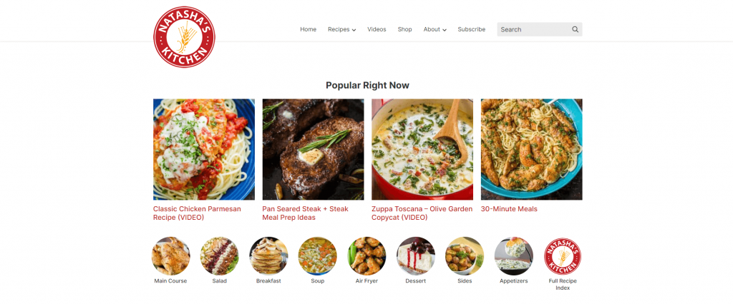](https://www.hostinger.com/tutorials/wp-content/uploads/sites/2/2022/03/natashas-kitchen-blog.png)**

As previously mentioned, blogging has also become a profitable career choice, especially during the pandemic. In fact, **over 50% of blogs** gained traffic, and about 35% of bloggers increased their revenue in this period.

Many organizations and businesses use blogs as part of their content marketing strategies to boost brand awareness and increase conversions.

A business’s blog content usually focuses on industry-related information that may interest its target market. Often, a team of writers runs the blog instead of a single admin.

Take a look at **Evernote’s corporate blog**. It shares tips on productivity and organization, as well as how its products help optimize these processes. The brand also uses its blog to share feature and company updates.

**[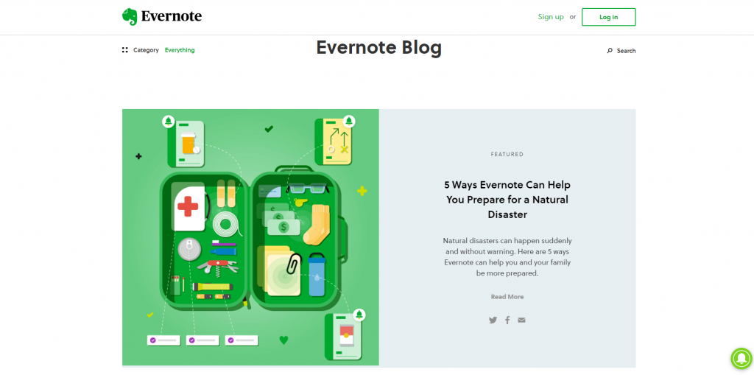](https://www.hostinger.com/tutorials/wp-content/uploads/sites/2/2022/03/evernote-blog.png)**

## What Makes a Great Blog?

If you plan to create your own blog, it is helpful to know what makes an excellent one in the first place. Typically, you can expect to find the following elements in successful blogs:

* **High-quality blog content.**The content should demonstrate **expertise, authoritativeness, and trustworthiness (EAT)**. It is also important to use easy-to-understand language and formatting to make the blog post digestible.
* **Inviting headlines.** These reveal what the content is about and help attract visitors to the content, as **around 80% of people** will click search engine results if the headlines are compelling.
* **Regularly-updated content.** A regular publishing schedule helps people know when to visit the blog for new content. Search engines also **prioritize fresh and up-to-date content**, helping increase rankings and website traffic. Atleast 3 times in a week, your blog should be updated.

## Types of Blogs

* **Personal blog.**This type of blog usually works like an online diary where the blogger shares opinions, often not aiming to reach a target audience or sell an item. Personal blogs can discuss various subjects, from family events and self-reflection to work projects.
* **Niche blog.** Provides information on a particular topic, usually related to the blogger’s passions, skills, and knowledge. Examples of this blog type include **book blogs**, food blogs, and lifestyle blogs.
* **Multimedia blog.** It uses a blog format but publishes multimedia content, like videos and podcasts, instead of written posts. It also usually includes the video or podcast’s summary, table of contents, and essential quotes.
* **News blog.**Content on this blog focuses on the latest happenings and new releases in a specific industry. Unlike other blogs, news blogs typically do not usually include opinions or personal content.
* **Company or business blog.** Its primary purpose is publishing content relevant to a company’s industry or updating the target market regarding any changes within its business. It may be a section on a company website or an independent site.
* **Affiliate blog.** A blog based on **affiliate marketing** – the practice of promoting a third party’s products and services. Affiliate blog owners will receive a commission when someone purchases from their custom links. Typical articles on this blog include product reviews and “best-of” listicles.
* **Reverse blog.** Also known as group blogs, multiple authors create blog posts on related topics and the blog owner is the one who proofreads and posts content.

Some blogs focus on a specific category, but it is also possible for a blog to combine several types. For instance, A blog contains posts with affiliate links and multimedia content.

## What Is the Difference Between a Blog and a Wiki? (Optional)

A blog is usually created and owned by an individual or organization to share information. It can have a single writer or many blog authors.

In comparison, a wiki is a collaborative website where many people can add, modify, and publish content.

Blog post timelines and comments are generally important to indicate the most recent updates.

Meanwhile, an article’s publication date in a wiki matters less as these are constantly updated once new information is available.

Compared to blog posts, which often value credits, creating and editing content in a wiki is mostly anonymous. Here, the information is the focus, not necessarily the contributors.

Wikipedia is one of the most famous examples of a wiki. The site is written and maintained by volunteers worldwide. Content editing is open for everyone, but creating an account is necessary to start new pages and upload images.

**Why Do You Need Your Own Blog?**

For personal use, blogging is a great way to express thoughts and opinions, while businesses can create a blog to educate their target audience.

Moreover, now everyone can start a blog. Unlike the early days of blogging that required coding skills to even update a blog post, people can now use blogging software such as WordPress, Blogger, and Zyro. It lets people create a blog within minutes without worrying about technical complexities.

However, to become successful bloggers, owners need to identify the reasons and purposes for maintaining their blogs.

Here are six reasons to start blogging:

**Share your knowledge.** Many people blog to share their experiences without having to depend on journalists or media companies. When people have their own blogs, they get to control the style, language, and information.

**Establish a personal brand.** A blog is a great platform to demonstrate your skills and knowledge, helping you make a good impression on employers and stand out from the crowd. In fact, many professionals today have succeeded in landing jobs thanks to blogging.

**Make money.** Making money blogging is possible for most blogs, especially those with a huge reader base. Blog owners can create sponsored blog posts, display ads, or sell their own products and services.

**Improve a website’s online visibility.** Websites with a blog have 434% more indexed pages in search engines, increasing the chances of ranking higher in search results. Also, it will help people find your content easily when searching for your name or brand online.

**Acquire new customers.** After reaching top rankings, a blog with relevant content can eventually bring more traffic and leads, as 81% of shoppers conduct research online before making a purchase.

**Build an online community.** Blogs provide a forum where visitors can comment and interact with the authors.

## How Do Bloggers Get Paid? (Optional)

Bloggers’ earnings depend on their traffic and monetization methods. Generally, blogs with hundreds of thousands of web page views have an easier time generating revenue by selling products or displaying pay-per-click (PPC) ads.

Bloggers can also encourage readers to buy products using their affiliate links and work with brands for sponsored posts.

Those who want to start a blog and make money have to focus on building their audience first to generate a stable income.

Picking a profitable niche is also important if you aim to make blogging your career choice. Profitable niches offer better opportunities, such as high-paying affiliate offers and ads from paid advertising networks.

Choosing a niche based on a passion sometimes does not equal consistent profit. For example, travel bloggers might experience traffic and revenue drops due to travel restrictions.

Some of the top profitable niches are:

* **Insurance.**It is the highest paying niche with **an average CPC of $17.55** in several countries like the United States, Australia, and Canada. Popular keywords within this niche include life, car, and health insurance.
* **Online education.** Flexibility and convenience are the primary reasons people choose online education. In fact, **the eLearning market size** is estimated to surpass in 2022.
* **Digital marketing and advertising.**The **digital marketing industry** has grown outstandingly during the pandemic. Take advantage of this high-demand topic to post content on social media marketing and brand management.
* **Personal finance.**Money is an evergreen blogging niche. In addition to writing blog posts on money management and investment, bloggers can sell online courses, eBooks, and finance consulting services.
* **Lifestyle and wellness.**Some of the top categories within lifestyle blogs include personal care, wellbeing, and fitness.

## What Do You Need to Start a Blog?

Now that we covered the basic concept of blogging – from what is a blog to benefits and types, it is time to discuss the essential elements for creating your first blog.

Six elements to prepare before starting a blog include:

* **Domain name.**It is your blog’s address, like yourblog.com. Ideally, a domain name should represent your business name or the blog’s general topic. Check whether the name is available using our **domain name search tool**. If you are still unsure about naming your blog, use **blog name generators** to brainstorm options.
* **Web hosting service.**You’ll need hosting to store all blog files, including images and code files, and make them available for internet users. Generally, **WordPress hosting** is a great solution for a small personal or lifestyle blog, while **Cloud web hosting** is ideal for heavy-traffic blogs.
* **Blogging platform.**You can set up your blog using a content management system (CMS) like WordPress or a website builder like Zyro. Users who create a WordPress website are usually looking for complete control and extensive customization, while website builder users prefer its quick setup and beginner-friendly interface.
* **Content writing skills. Writing a blog post** is different from writing academic essays or books. Consider joining a free online course like SurferSEO’s **SEO Writing Masterclass** to develop your content writing and SEO skills.
* **Theme or template.** This is a pre-made web design for your blog. Most CMS platforms and website builders provide **free templates**, but it is possible to purchase a custom **blog theme** from a third-party marketplace like **ThemeForest** or even design it yourself.
* **Blogging tools.** Many tools can help produce better blog posts and manage your blog. For example, use **Trello** to create an editorial calendar and**Yoast SEO to optimize the content** for search engines.

Another vital element to start a blog is confidence. Many beginners think they are not experts in the field, which holds them back from sharing content. To overcome this, start by sharing personal experiences and using storytelling.

## Conclusion

Creating a blog has many advantages. It can help individuals build a personal brand and generate an extra or full-time income.

If you plan to blog as a way to **make money online**, consider picking a profitable niche to maximize the opportunities for better-paying sponsored posts or affiliate offers.

Business owners also create blogs to improve their website rankings on search engines, attract customers, and develop a loyal online community.

Whatever your purpose is, great blogs don’t focus on simply publishing content. It is essential to consider its quality, consistency, and overall web design.

If you want to create your first blog, ensure that you purchase a suitable domain name and the **best hosting plan** for you. Then, select a blogging platform and develop your content writing skills by joining online courses.

**Blogging Platforms**

**The Top 5 Best Blogging Platforms and Blog Sites for 2022**

* [**WordPress with Hostinger**](https://www.quicksprout.com/go/qsp12204/) — Best overall
* [**Wix**](https://www.quicksprout.com/go/qsp10207/) — Best for beginners building a professional blog
* [**Squarespace**](https://www.quicksprout.com/go/qsp11313/) — Best for artists, and designers
* [**LinkedIn**](https://www.quicksprout.com/go/qsp13567/) — Best for networking
* [**Medium**](https://www.quicksprout.com/go/qspnm0020/) — Best for writing to a built-in audience

If you want to turn a profit on your blog, use WordPress, Wix, or Squarespace. You’ll be in complete control of your site and everything that’s on it. For people who want to blog with WordPress, we recommend using Hostinger as a web host to keep your speed high and costs low.

Medium or LinkedIn are great for hobby blogs and making connections. but not making a living. They are free, but you don’t get to choose how your blog looks and adding your style is half the fun.

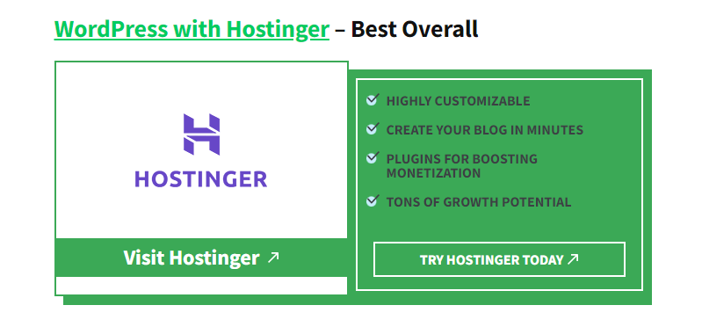

WordPress is the most popular blog platform out there—and for very good reason. it’s free, you just have to pay for hosting.

We recommend Hostinger for WordPress hosting because it’s the best price for a simple setup. You’ll have a WordPress site in a few minutes with Hostinger.

It’s a highly customizable content management system (CMS) for bloggers who want to build out a site for their business. It’s also great if or if you plan to scale your blog for profit.

The reason? WordPress is *open source*. That means they don’t keep their source code a secret. Developers can go in and create widgets, plugins, and other tools to customize WordPress blogs—so youcan create *any kind of blog you want*.

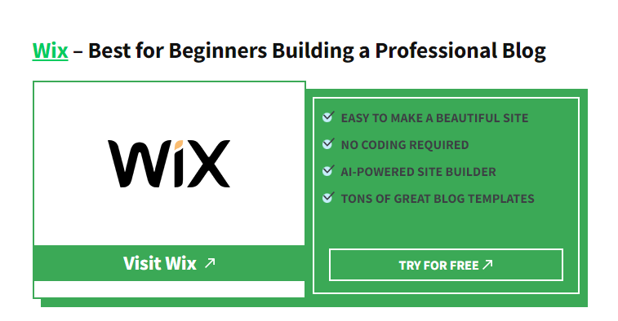

Wix gives beginners a way to make it look like *professionals*designed their blogs—all without needing to learn code or web development.

In fact, our panel of users gave it high marks for ease of use, praising the platform for its usability and a relatively simple learning curve.

One user told me, “I think it’s as straightforward as it can get for people with no coding background.” They created their site with ease without running into any stifling restrictions.

Another user called out the drag-and-drop editor’s intuitive UI and its tools to create individualized layouts and designs.

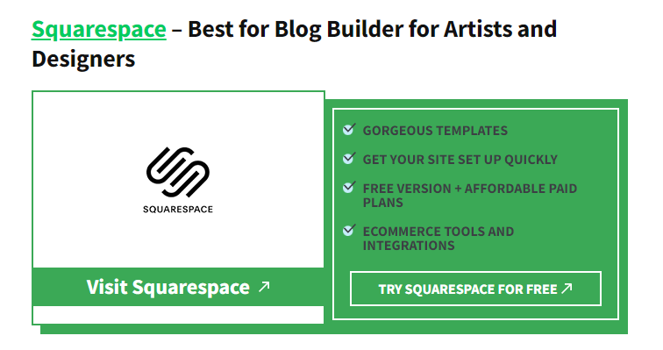

The first thing I notice whenever I go onto a Squarespace blog is how *gorgeous*it typically looks.

Photography and graphic designs seem to leap off the screen. The blog owners themselves seem to always be artistically-minded like illustrators, photographers, graphic designers, home decor experts, and more

They were made up of a website design expert who teaches readers how to make stunning sites, a gardening influencer who frequently showcases mouth watering photos of his homegrown vegetables, and an interior designer who likes to flex their room designs off in gallery posts.

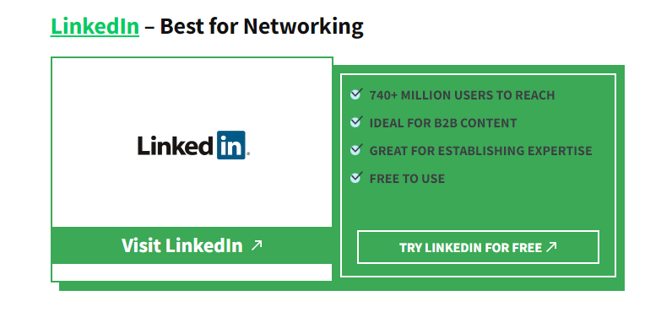

LinkedIn gives you a built-in audience for business professionals of *all*stripes from HR, digital marketing, finance, tech, and more.

Many of them are highly active on the site, frequently sharing thought leadership and articles with one another via their LinkedIn feed.

So if you’re interested in establishing yourself as an influencer or thought leader in your business space, the audience on LinkedIn is your bread-and-butter.

The platform has a ready-made culture and set of expectations that a business blogger would dream of creating on their own site. The challenge for you is creating compelling and share-worthy content

After all, LinkedIn is a social network. Your influence grows in proportion to the size of your network. The more posts you publish, the more connection requests and followers you’ll attract.

Since it’s a social network for industry professionals, that makes it a great channel to access prospects and get quick feedback from peers on your articles. You have an opportunity to put your thought leadership in front of everyone from potential clients and customers, to recruiters, to influencers in your field.

And, you can turn your audience into partners and customers.

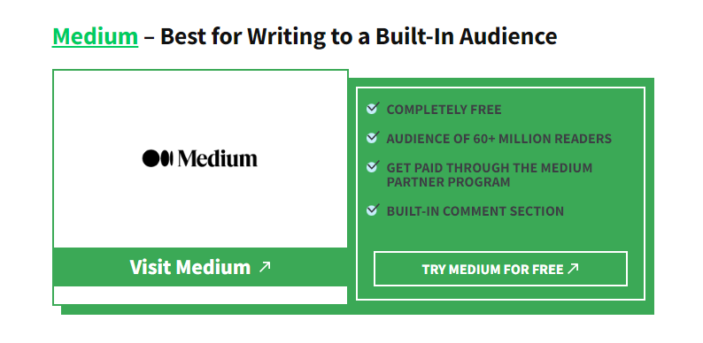

Medium is easily one of the most polarizing platforms out there—and it’s certainly the most controversial one on our list.

It’s home to bloggers focused on crafting niche content for readers. It’s also where you can find some of the most thought-provoking, incendiary content online.

What really makes Medium stand out for writers is their built-in communities of readers. People can browse a vast library of publications and topics, find your blog, and subscribe to it with a single click–they can even choose to get your blog posts sent to their email inbox every time you post. Writers can post pieces under their personal account, a publication they own and run, or submit their writing to publications for a chance to be published on other Medium blogs and put in front of even more readers.

We chose our top five blogging platforms by focusing on following four essential qualities:

1. Easy Learning Curve
2. Niche-Friendly Customization
3. Audience-Building Tools
4. Profit Potential

“It’s just plugging and chugging and going,” one user told us. “Even if you have no writing experience, and just want to write, it’s not hard to get started and find an audience.”

**Recommended Blogging Resources & Tools**

 will add to these lists as I come across new blogging resources that I recommend.

**Blog Platforms**

**WordPress**

My recommendation for blogging platforms is pretty clear – **WordPress.org**. For the last 10 years I’ve not build a blog on any other platform and it is also the blogging platform of choice of most other bloggers today.

A couple of other platforms exist of course including:

* [**WordPress.com**](https://wordpress.com/alp/?aff=12277) – a free hosted blogging platform
* [**Blogger**](https://www.blogger.com/) – another free hosted option – owned by Google

**Recommended Reading:** [**Choosing a Blog Platform**](https://problogger.com/choosing-a-blog-platform/)

**Hosting**

There are many hosting services available for bloggers.

If you’re just starting out or have a smaller blog I highly recommend you check out **BlueHost** who have put together a special discount offer for ProBlogger readers.

**BlueHost** – WordPress has been recommending Bluehost for web hosting since 2005. With 1-click WordPress installation, 24/7 support, and a super affordable rate, Bluehost is a great option for building your first website or blog.

#### How to create a blog (in 6 easy steps)

1. **Pick a descriptive name for your blog.** Use [Domain Wheel](https://domainwheel.com/) to find the perfect domain name for your blog.
2. **Buy a domain and get hosting for your blog.** We recommend buying hosting from [Bluehost](https://bluehost.com/track/codeinwp/freeblogsitesb) (from $2.75/month) and getting your domain name free of charge.
3. **Install WordPress.** You can install WordPress via the Bluehost interface with a few quick clicks.
4. **Find the perfect**[WordPress theme](https://themeisle.com/wordpress-themes/?utm_source=themeisle&utm_medium=themeisle_blog&utm_campaign=best-free-blogging-sites)**or template.** Personalize the design of your blog to match your taste.
5. **Get some**[must-have WordPress plugins](https://themeisle.com/blog/must-have-plugins-for-wordpress/)**and add-ons.** Give your blog more features like social sharing and [image optimization](https://themeisle.com/blog/image-optimization-in-wordpress/).
6. **Launch your blog and start sharing your voice with the world.** Start writing, sharing and engaging with your followers on your favorite subject.

## 5 Tips For Increasing Your Social Media Engagement

**1. Post Content Worth Engaging With**

If you want to increase social media engagement, you need to create content that people can engage with. It could be a poll on Twitter, a video people can relate to, a graphic that makes people laugh, or a product photo that encourages someone to tag their friends. Choose to post content that will receive a positive reaction from people. Is your post about something beautiful, inspiring, funny, or relatable? Choose content that’ll drive an emotional response from people. As you’re building a store avoid posting things that’ll make people angry at your brand such as sensitive issues.

**2. Respond to All Comments**

To increase social media engagement, you need to be social too. When customers send you a message or leave a comment on a post, they’re giving you an opportunity to talk to them. Whether they leave a positive or negative message, you should be responding to each customer. You can show appreciation for positive messages and suggest a resolution for negative ones. The only time you wouldn’t respond to a post is if someone tags their friend as they’re not directly engaging with you.

**3. Encourage Readers to Comment, Like, and Share**

When you create a post always add a call to action at the end of it. You can ask people to like, comment, and share with their friends. People are more likely to share a post if you ask them to.

**4. Start a Facebook Group**

Facebook groups are a great way to increase social media engagement. Groups are generally more social than pages as members are free to post their questions at anytime. By having a group, you can allow your customers to communicate with each other. This will allow them to get to know other people in their niche. You should also be active in your own community and strengthen your relationships with others. You’ll should moderate posts within the group to avoid spam. But also to ensure that the group remains valuable to its community.

**5. Run Contests and Giveaways**

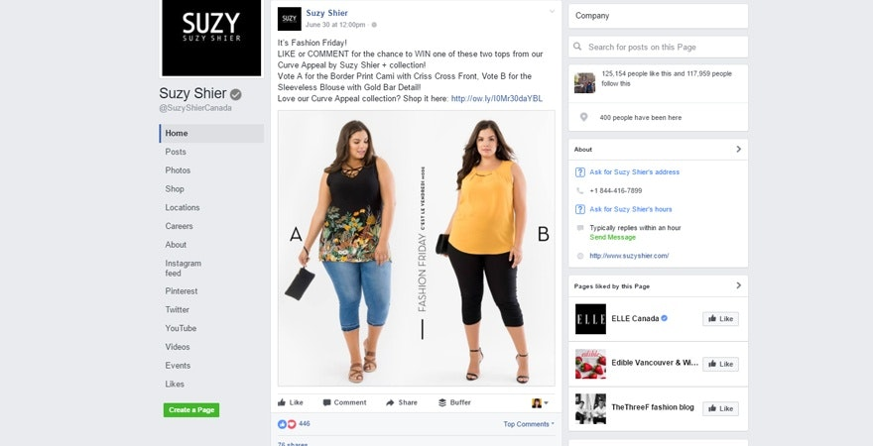

The easiest way you can increase social media engagement is to run contests and giveaways. You can ask people to take certain actions such as visiting a landing page on your website (that you can retarget). You can use tools like Rafflecopter which you can use to grow your social media following and increase social media engagement as contest requirements. You’ll need to give a prize to a winner but the prize can be expensed by your business.

**6. Use Images in Every Post**

According to Buffer, tweets that include images tend to gain 150% more retweets than tweets that don’t include them. Images capture more attention when scrolling through newsfeeds than just plain text. Adding relevant images to your post will help encourage more social media engagement.

**7. Get More Followers**

Having followers will surely help you increase social media engagement. Those with under 100 followers will receive less engagement overall than brands with tens of thousands. Social media engagement can be a numbers game. If you have a bigger audience, you’ll be more likely to have a higher level of engagement on your posts. You’ll still need to ensure that the quality of your social media posts is high. But it’s a lot easier to receive post engagement when you have a big audience.

**8. Ask a Question**

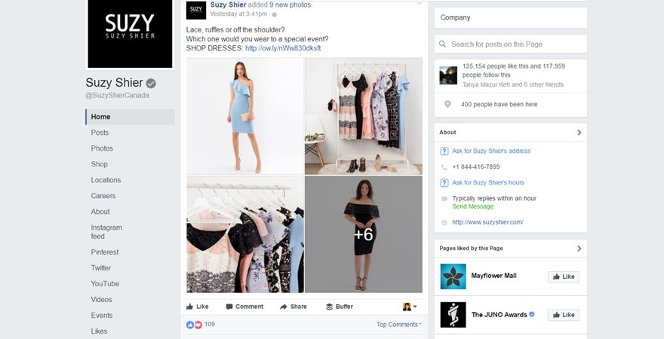

When you post on social media, an easy way to engage your fans is to ask a question. Asking a relevant but fun question is a great way to get your customers to leave a comment on your post. For example, you can create a post that compares two different dresses and ask ‘Which would you rather wear on date night?’ This allows you to incorporate your product into the question while still being playful with your audience.

**9. Post Multiple Times Daily**

To increase social media engagement, you’ll need to post regularly on your pages. On average, 2-3 posts per platform per day will help you build an engaged audience. If you post too much, you may annoy your audience, which can result in unfollowers. You’ll also want to post at the best times. On average, between 1-3pm is the best time to post on most social networks.

**10. Optimize Your Headlines for Engagement**

Your headlines should be honest yet compelling. Whether you’re trying to drive traffic back to your blog post or product page, you should use a tool like CoSchedule to create a captivating headline. CoSchedule allows you to optimize your headlines to encourage engagement such as click through. You’ll receive a score for your headline and can make changes to increase your score. Aim for a score above 70.

**11. Share Content That’s Relevant to Your Audience**

Who are your customers? What are their interests? What types of posts do they prefer? How do they consume information? Would they prefer videos, blog content, or image posts? Focus on creating content your customer would enjoy. You’ll likely need to experiment with different types of content to see which gets the most engagement. If you notice that videos perform well on your fan pages, then create more video content.

**12. Use Two Attention Grabbing Words at the Beginning of a Post**

When I first started managing social media pages, I experimented a lot. I noticed that when I capitalized two important words before a post, I generally received higher engagement. For example, if I was running a giveaway or contest I would write: ‘GIVEAWAY ALERT:’ or ‘CONTEST ALERT.’

**13. Go Above and Beyond in Your Interactions**

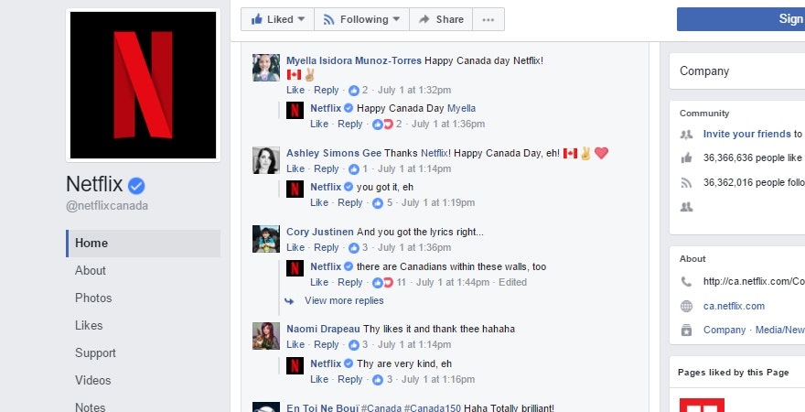

Brands like Netflix crush their social media engagement by interacting with their fans. They’ll regularly joke around with them. For example, on their Canada Day post, all of their responses to their fans made Canadian references such as using the word eh. Each customer response was different. So avoid doing canned responses with your customers. If you routinely offer a fun and enjoyable customer experience on your pages you’ll increase social media engagement.

**14. Host a Weekly Twitter Chat**

Another way to increase social media engagement is to host weekly Twitter chats. You’ll want to create a hashtag for your chat and let your audience know about it. The weekly chats serve as a real-time way to interact with your customers. Many Twitter chats include giveaways for responding to questions to entice higher levels of social media engagement. The Twitter chat hashtag can trend if you get a high number of tweets using the hashtag during that time.

**15. Use Emojis**

According to OPUSFidelis, using emoticons can increase social media engagement. Each emoticon can increase engagement by a different amount. A smiley face can boost interaction by 25% whereas a grimacing emoticon can increase engagement by 138%. Those who use emoticons in their social media posts tend to see an increase in likes, comments, and shares.

**How to define and reach your target audience on social media**

Defining a target audience can be one of the most challenging aspects of marketing. But once you have a clear idea of who your audience is, you’ll run more relevant campaigns with better returns.

**What is a target audience?**

In simplest terms, a **target audience** refers to the group of people that are most likely to be interested in your product or offer. And members of this group share common traits.

Let’s look at a few examples of target audiences. Canva, the online design tool, has a large target group of designers and design enthusiasts, which could be broken down to how these groups use the tool.

For instance, one of Canva’s target audiences is teachers, who use the tool to create worksheets, infographics or posters.



Another major target audience group for Canva is social marketers who need to create captivating visuals for their brand’s social media and digital campaigns.

**Why should you define your target audience?**

Why is defining a target audience so important? Below are some of the top ways in which you can benefit from marketing to a targeted audience:

* Focusing on a few specific target groups allows you to advertise more effectively.
* This also means allocating money and resources on relevant consumer groups.
* Knowing a specific audience group to target also helps solidify a brand voice that resonates. This amplifies your **social media branding efforts**.
* When you market to a highly specific target audience, you can develop messaging that truly resonates with them. This makes it easier to connect with them and earn their loyalty.

Now that you know how to define a target audience, let’s find out who are target audience is.

**Resources and data for finding your target audience**

Defining and refining your target audience can be an ongoing process, especially as you gather more and more data to inform your process.

**Take a closer look at your existing audience**

Start by taking a closer look at who are already following you or buying from you. The goal is to identify who wants to engage with you on social media and gain a better understanding of them.

Here are a few questions that’ll help you with this step:

**1. Who is your current audience?**

Monitor who follows you on social media and interacts with your posts. Who likes, shares, comments on your content? Then narrow down on key common characteristics such as age, location, language, interests and so on.

So who is your target audience? The answer lies with the people who identify with your brand.

**2. What kind of information are they looking for and why?**

The next question to ask is why and what information is your audience following you for?

Understanding the kind of information followers seek will help with understanding your audience. And you’ll identify their needs and how to approach them on social media.

It’s good to note that people will have different reasons why they follow brands on social media. And you’ll have to adapt your [**social media content strategy**](https://sproutsocial.com/insights/social-media-content-strategy/) accordingly.

According to the [**Sprout Social Index™: Above and Beyond**](https://sproutsocial.com/insights/data/2020-index/), the top four most commons reasons why consumers follow brands on social media are to:

1. learn about new products or services (57%)
2. stay up to date on company news (47%)
3. learn about promotions or discounts (40%)
4. be entertained (40%).

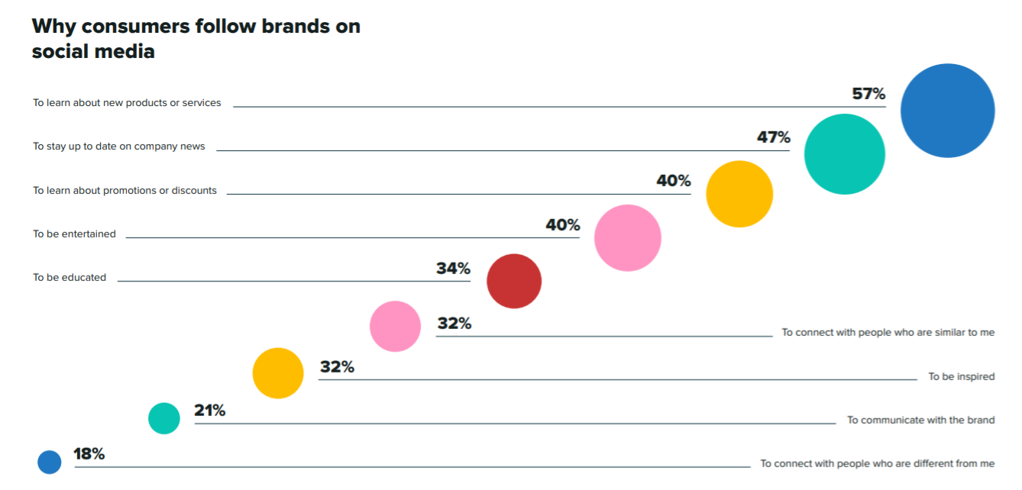

**3. Where do they go for this information?**

Which social media networks does your target audience frequent the most? Based on your research, where have you noticed your audience the most? To make an impact, make sure that you’re reaching your target groups where they’re the most active.

For instance, launching a Twitter campaign doesn’t make sense if a majority of your target audience is most active on Instagram. Understanding what your audience wants and on which platform will define your content strategy.

**4. What are they talking about?**

This is one of the most critical questions that can give you the most insight about your target audience. Instead of guessing, you’ll know exactly what your audience is talking about.

What are your audiences likes and dislikes? What challenges and what solutions are they looking for? What are they saying about your brand or products? Knowing the answers to these questions will help you narrow down on their biggest pain points and desires.

A platform such as Sprout Social makes distilling through online conversations easy with its **social media listening tool**. This tool tracks conversations around your brand, examines audience preferences, identifies trending topics and more.

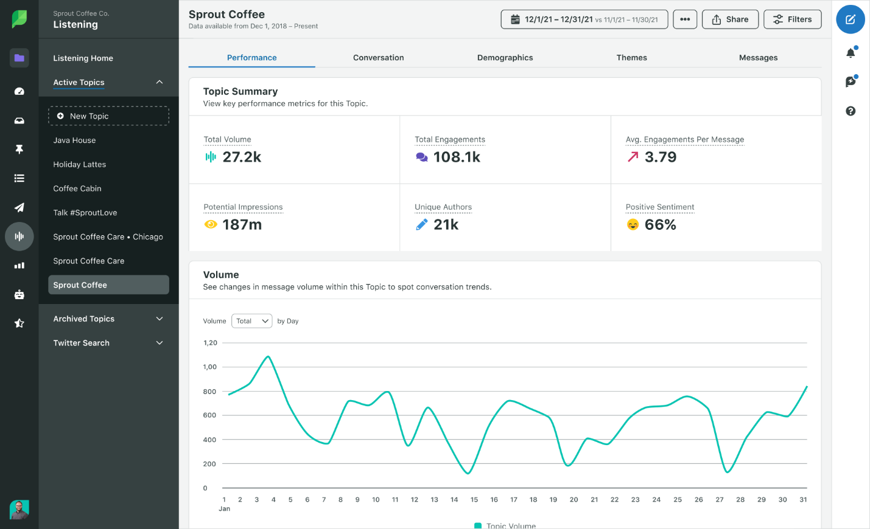

**5. Who do they trust?**

Trust is important when building relationships with your followers? Think about your social habits: do you trust any brand online? Do **online reviews** from other customers way your purchase decisions?

Think about how your business handles its **reputation** as well. Do you respond to all inbound messages or social mentions? Being present for your brand and for your audience is important to build trust and attract your target audience.

**Define the key benefits of your products or services**

Now that you’ve defined your target audience, how can you solve their pain points with your products or services? What value does your business offer? By defining these pain points and your key benefits, you’ll have a clearer idea on how to best position your business in a way that resonates with your target audience. Plus, this will also help you narrow down the unique advantage that you have over the competition.

One of American Express’s biggest competitive advantages is the loyalty programs it has for customers. And to promote this unique selling point, the company leverages Amex Ambassadors for its social media content strategy.

**Check out the competition**

To properly define and reach your target audience, you also need to take a look at what the competition is doing. Ask questions such as:

* What types of people are your competitors targeting?
* How are they reaching out to their target audience?
* What are they doing right?
* What’s missing from their strategy?
* What key benefits are they emphasizing in their marketing?
* How often are they posting?
* Which content formats seem to work the best for them?
* What kind of tone are they using?

Again, Sprout can help uncover these answers with social listening. Create listening topics around your competitors to understand the social chatter around their brands.

**Create content for your social media target audience**

Now that you have all this insight about your target audience, it’s time to start creating content.

Here are a few best practices to guide you:

* **Try A/B testing** different content elements, formats, timings and more. As a result, you’ll fine-tune your content strategy to the types of posts your target audience tends to engage with. Monitor what kind of captions they like, **which timing works best** to engage them and so on.
* Remember to **create content for different stages of the purchase funnel**. Entertaining content may be great to capture attention at the awareness stage, for example. But for those at the consideration stage, informative and instructional pieces work better.
* **Be more direct with your audience research**. Instead of assuming or using solely analytics data alone, consider what your followers really think by putting those insights into context. Conduct polls and ask them questions so you can engage them better.

**Social Media Do’s and Don’ts**

Do’s

* Do post regularly
  + You don’t need to post every day, but it will help your posts get boosted through the algorithm if you post on a somewhat consistent schedule
* Do considering posting different content on different channels
  + Think about who your audience is on each platform and if the content is appropriate for that audience
* Do add captions to videos
  + This makes your content most accessible for those with disabilities
  + Many people watch videos on mute
  + Facebook and Instagram now have built in caption creating features
* Do engage with partner pages
  + Like and comment on posts from partner pages
  + Engaging with audiences outside your own content will introduce your page to potential new followers
  + If you engage with content on partner pages, they are likely to return the favor and engage with your content
  + Share content from other pages if it is content that is appropriate for your audience as well
* Do make sure your content is at least 50% original content
  + While sharing other page’s content is an easy way to get posts out, make sure you are providing original content for your audience at least half the time
* Do use a combination of photos and graphics on your page
  + Studies have shown that images with no text or a small amount of text perform better than images with lots of text
  + The point of an image on social media is to grab the user’s attention, not to tell the user everything they need to know. There is space in the post copy to add more details.
* Do consider size when creating graphics for social media
  + Every platform is slightly different and all are constantly changing – look up current preferred image sizes when creating graphics

Don’ts

* Don’t post graphics with a lot of text
  + Studies have shown that images with no text or a small amount of text perform better than images with lots of text
  + Try to keep text to 20% or less of the graphic
* Don’t include a URL on a graphic
  + Users cannot click on URLs on graphics. Only include if it’s a very short vanity URL
* Don’t post the same content repeatedly
  + It is okay to sometimes repurpose content if enough time has passed since it was last posted, but audiences expect fresh content and are likely to unfollow if the content is repeated too much or stale
* Don’t post irrelevant content
  + Be sure to post content that is relevant to the topic of your page
* Don’t create social media pages on new platforms if you do not have the capacity to maintain the page
  + It’s better to have one page that performs very well and has an engaged audience than to have seven pages that aren’t maintained well and don’t have fresh content to keep audiences engaged.

whenever there are wrongs, there are always many rights to counteract them. As a small business, here are some things you need to avoid and some things you need to do to help you get on the right track of using social media effectively to help you increase traffic, leads and sales.